EXPERIMENT 12
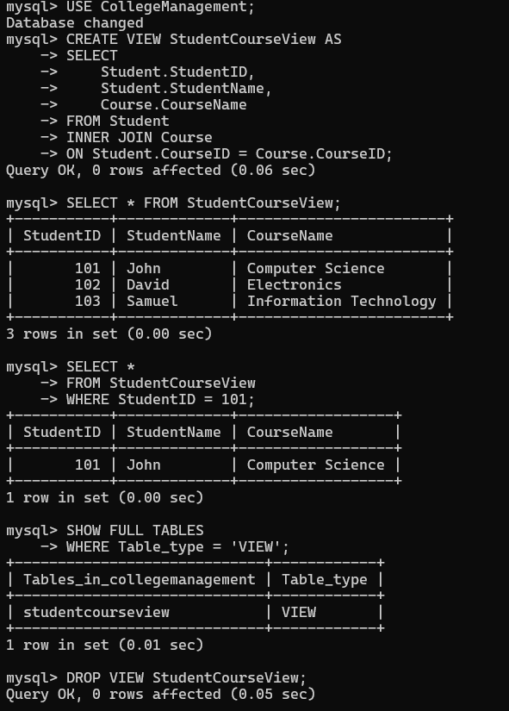
VIEW

